**Challenge1**

**Index.html**

<!DOCTYPE html>

<html lang="en">

<head>

    <meta charset="UTF-8">

    <meta http-equiv="X-UA-Compatible" content="IE=edge">

    <meta name="viewport" content="width=device-width, initial-scale=1.0">

    <title>Babel Introduction</title>

</head>

<body>

    <script src="challenge1.js"></script>

</body>

</html>

**Challenge1.js**

let myArray=[1,2,3];

// destructuring

function fn1(array){

    let [a,b,c]=myArray;

}

function fn2(array) {

    let [a, b, c] = myArray;

  }

console.time("Function 1")

fn1();

console.timeEnd("Function 1");

console.time("Function 2")

fn2();

console.timeEnd("Function 2");

**Result**

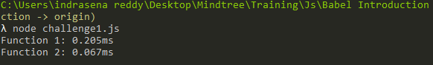

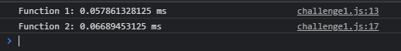

**Challenge2**

**Index.html**

<!DOCTYPE html>

<html lang="en">

<head>

    <meta charset="UTF-8">

    <meta http-equiv="X-UA-Compatible" content="IE=edge">

    <meta name="viewport" content="width=device-width, initial-scale=1.0">

    <title>Babel Introduction</title>

</head>

<body>

    <script src="challenge2.js"></script>

</body>

</html>

**Challenge2.js**

function featureCheck(){

    try{

        eval("`Hello`");

    }

    catch(e){

        return false;

    }

    return true;

}

if(featureCheck()){

    console.log(`Hello from ES6`);

}

else{

    console.log("Hello from ES5");

}

**Result**

**Edge browser**



**Chrome browser**



**Challenge3**

**Index.html**

<!DOCTYPE html>

<html lang="en">

<head>

    <meta charset="UTF-8">

    <meta http-equiv="X-UA-Compatible" content="IE=edge">

    <meta name="viewport" content="width=device-width, initial-scale=1.0">

    <title>Babel Introduction</title>

</head>

<body>

    <script src="challenge3.js"></script>

</body>

</html>

**Challenge3.js**

function featureCheck(){

    try{

        eval("`Hello`");

    }

    catch(e){

        return false;

    }

    return true;

}

function insertScript(type){

    var el =document.createElement("script");

    el.src= "src/" + type+ ".js";

    document.body.appendChild(el);

}

if(featureCheck()){

    insertScript("es6");

}

else{

    insertScript("es5");

}

**Es5.js**

console.log("Hello from ES5");

**Es6.js**

console.log("Hello from ES6");

**Result**

